Question 1 Explanation

1. void add(product p[], int &count, int &n)
- This function adds a new product to the inventory.
- It takes an array of products, the current product count, and an index n.
- It prompts the user for product details such as name, category, price, and quantity.
- The product ID is automatically assigned based on n.
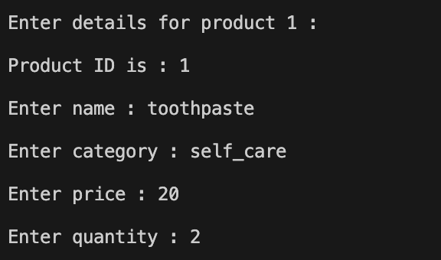
- Increments the count and n variables to track the total number of products.

2. void display(product p[], int &count)
- Displays details of a specific product based on the provided product ID.
- If an invalid ID is entered, it informs the user that the product does not exist.
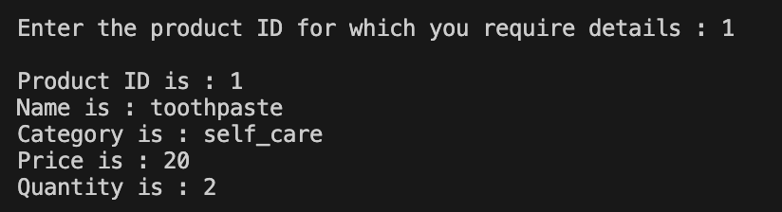
3. void total(product p[], int &sum, int &count)
- Calculates the total stock value of all products.
- The total value is computed as the sum of (price * stockQuantity) for each product.
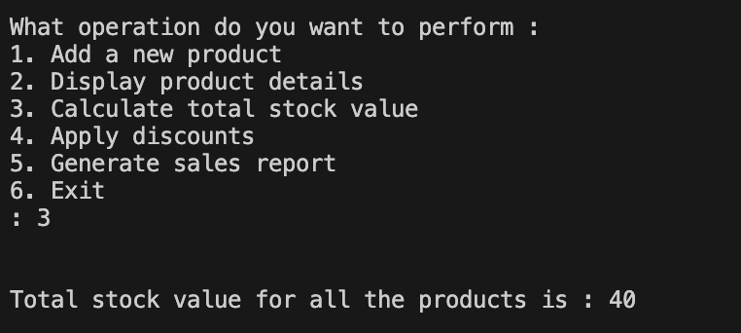
- If no products exist in inventory, it notifies the user.

4. void discount(product p[], int &count)
- Allows the user to apply a discount to a product.
- The user enters a product ID and a discount percentage.
- The program calculates the new price using the formula: price = price - (price * discount / 100).
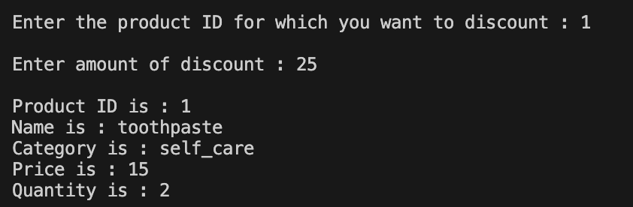
- Displays the updated product details after applying the discount.

5. void report(product p[], int &count, int &sum)
- Generates a sales report by displaying all stored products and their details.
- Calculates the total revenue based on product prices and available stock.
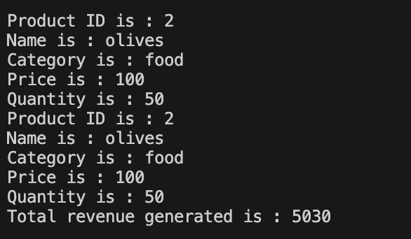
- If no products exist, it notifies the user.

6. main() Function
- The main function provides a menu-driven interface.
- Users can choose an operation by selecting a number (1-6).
- Uses conditional compilation (#ifdef) to enable or disable certain features based on preprocessor directives.
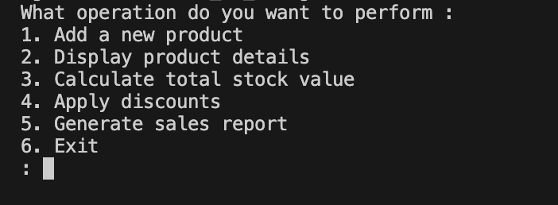
- The loop continues until the user selects option 6 (Exit).

